**Tutorial 39: Vue Router – Dynamic Links**

In this tutorial we will be creating a way to navigate to the JobDetails component and see the data related to the job we selected. When we click on the job title, will get navigated to the JobDetails component but the data shown on the screen will be determined by the route parameter.

Make sure **Tutorial 38** is complete to be able to move on to this tutorial or clone the [vue3-firebase-course](https://github.com/younggrasshopperza/vue3-firebase-course) repository and go to branch called **Tutorial-38** and navigate to the young-grasshopper-jobs folder.

**Step 1:** In the Job.vue file, inside the div tag calling the v-for, copy and remove the h2 tag with the value {{ job.title }} , create a router link tag that navigates to the JobDetails component. Inside the router link tag paste the h2 tag that was removed earlier.

Look at the example below (**Between line 4 and 6**):

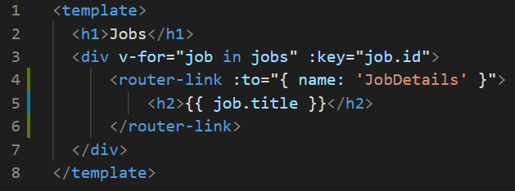

We now need to pass through the route parameter which will be the id of the current job that we are iterating through. We can pass a parameter by adding another key value pair inside the :to where the key is params and the value is an object, inside the object the key is id and the value is job.id. We can get the id because it is already in the original job object in the v-for.

Look at the example below (**Line 4**):

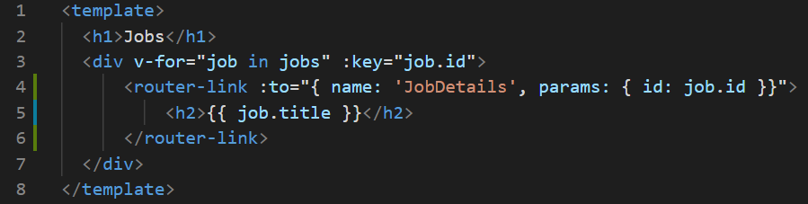

The id for Software Developer is **1**.

The id for Web designer is **2**.

The id for Project Manager is **3**.

Have a look at the code in the dev tools and see where the anchor tags is directing the user to.

**Output:**

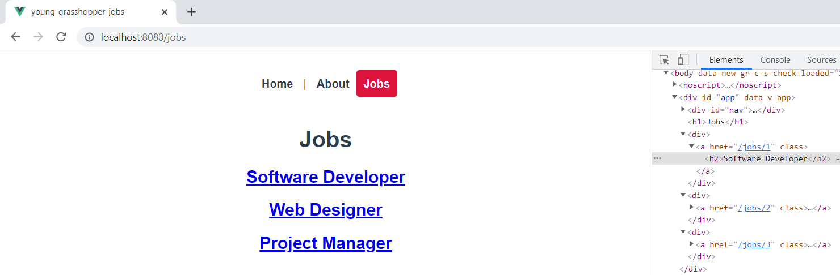

After clicking “Software Developer”

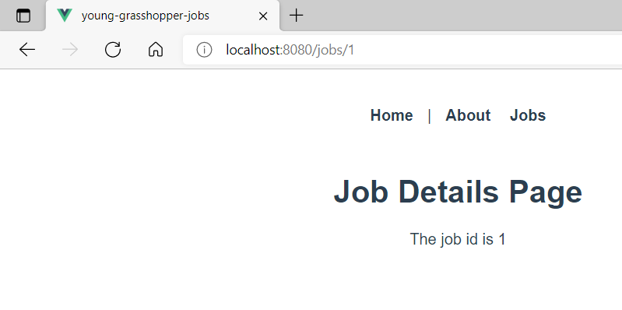

**Step 2:** Now that we are navigating from the Jobs component, localhost:8080/jobs to the JobDetails component, localhost:8080/jobs/1, we can also pass the route parameter from the jobs component as a prop in the JobDetails component. In our case, we can pass the id as a prop.

In the JobDetails.vue file, create a props property that accepts the id prop.

Look at the example below (**Line 8**):

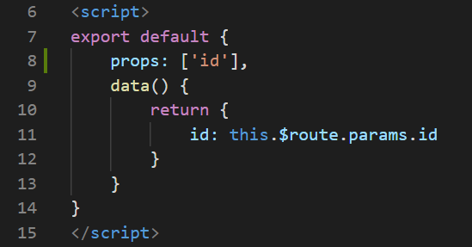

In the router folder, in the index.js file, inside the array of routes for the JobDetails component, we will include another key value pair, where the key is called props and the value is set to true.

Look at the example below (**Line 27**):

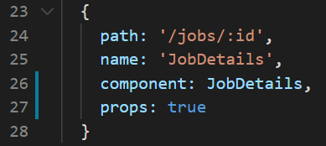

Now we can accept any route parameters as a prop. Vue will attach the parameter as a prop and we can accept the value as a prop.

We know longer need the id in the data property since the value of the id data property is the same as the props since they are both route parameters. We can comment out the data property and we will see that everything will exactly the same.

Look at the example below (**Between** **line 8 and 13**):

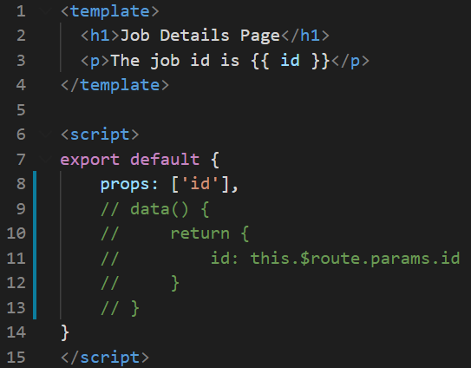

**Output:**

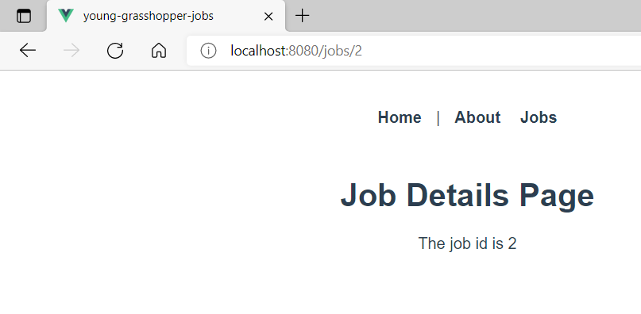

**Step 3:** in the Jobs.vue file, inside the div tag with v-for, add a class called jobs. You can paste the following css code:

.job h2{

    background: #f4f4f4;

    padding: 20px;

    border-radius: 10px;

    margin: 10px auto;

    max-width: 600px;

    cursor: pointer;

    color: #444;

}

.job h2:hover {

    background: #ddd;

}

.job a{

    text-decoration: none;

}

**Output:**

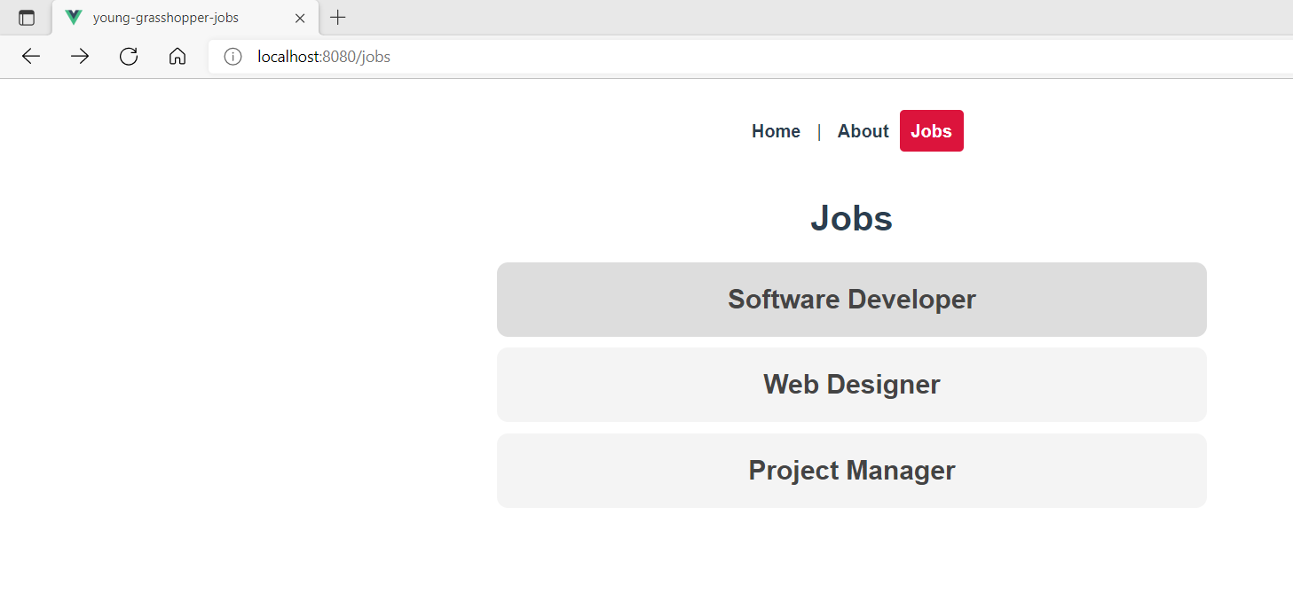

**You can view the code snippets from the** [**vue3-firebase-course**](https://github.com/younggrasshopperza/vue3-firebase-course) **repository under the Tutorial-39 branch**.